NAME: J SATYA SRIKAR
ROLL NO:A24126552259
BRANCH AND SECTION:CSM-B
COURSE NAME: FULL STACK WEB DEVELOPMENT
COURSE CODE:23CM4121

Experiment:03
Date:
Title: Write a program using JavaScript (arrays, functions)

Objective:
o study JavaScript arrays and functions by performing array operations, using built-in methods, creating different types of functions, and handling asynchronous data.

System Requirements:
- Hardware: Processor (e.g., Core i5), RAM (e.g., 8GB), Storage.
- Software: Operating System (e.g., Windows 11 / Linux), Code Editor (e.g., VS Code), Browser (e.g., Chrome), Runtime/Database (e.g., Node.js, MongoDB). [1, 2]

Source Code:
Arrays.js
//Nobe tire - Creation of an array
const arr = [1,2,3,4,5,6]
//Construction creation
const arr2 = new Array(1,2,3,4,5,6)
console.log(arr)
console.log(arr2)
arr.push(58)
console.log("pushed 58:"+"["+arr+"]")
arr.pop()
console.log("poped:"+"["+arr+"]")
arr.unshift(2)
console.log("unshifted 1:"+"["+arr+"]")
arr.shift()
console.log("shifted 1:"+"["+arr+"]")

//The Holy Trinity (Mid Tier)
//map function in array
const newarr = arr.map(
(num)=>{return num * 10}
)
console.log("mapped arr"+newarr)
const booleanArr = arr.filter(
(num)=>{return num%2 === 0}
)
console.log("booleanArr:"+booleanArr)
const total = arr.reduce((val1_starts_With_zero,val2_starts_with_first_element)=>{return})

//Finding Stuff
function greater(num){
return num>1;
}
console.log("Find Elements greater than 1",arr.find(greater))
console.log("Find index for number greater than 1",arr.findIndex(greater))
console.log("Does 7 is there in arr",arr.includes(7))
console.log("index of 6 "+arr.indexOf(6))

//slicing & Dicing
let sliced_arr = arr.slice(1,3)
console.log("sliced array",sliced_arr)
let spliced_arr = arr.splice(3,3)
console.log("spliced arr ",spliced_arr)
let unsorted_arr = [4,3,5,1]
console.log("Unsorted array:",unsorted_arr)
console.log("sorted array",unsorted_arr.sort())

//God Mode
// Destructuring
const person = {
firstName: "John",
lastName: "Doe",
age: 50
};
console.log("Before Destructuring:",person)
let {firstName, lastName} = person;
console.log("After Destructuring - firstName:",firstName)
console.log("After Destructuring - lastName:",lastName)
console.log("Both Names:",{firstName,lastName})

//Spread Operator
const first = [8,6,5,4,6,6]
const second = [1,2,4,5,6,7]
console.log("first and second",first,second)
const combined = [...first,...second]
console.log("Combined:",combined)

//flat
const Fa = [1,[3,4]]
console.log("Before flat:",Fa)
console.log("After Flat:",Fa.flat())
Functions.js
// Normal way of function
// You can call it up here!
console.log(greetOG("Bro"));

function greetOG(name) {
return `Sup, ${name}`;
}
// Function Expression
const greetMillennial = function(name) {
return `Hello, ${name}`;
};

console.log(greetMillennial("Bro"));
// Arrow Function (The Gen-Z Way)
const greetGenZ = (name) => {
return `Yo, ${name}`;
};

// THE GIGACHAD ONE-LINER (Implicit Return)
// If it's just one line of code, you can drop the {} and the 'return' keyword.
const greetFast = name => `Yo, ${name} no cap`;

console.log(greetFast("Bro"));

// Built-in Function
// Math.max() is a built-in function.
// You just hand it numbers and it does the math behind the scenes.
const highestScore = Math.max(45, 120, 13);
console.log(highestScore); // Output: 120

// Put 'async' before the arrow to unlock god mode
const fetchServerData = async () => {
console.log("1. Sending request to server...");

// The 'await' keyword tells JS to pause THIS specific function
// until the fetch finishes, while the rest of your app keeps running fine.
const response = await fetch("https://jsonplaceholder.typicode.com/users/1");
const data = await response.json();

console.log("2. Data secured!", data.name);
};

fetchServerData();
console.log("3. Doing other stuff while waiting...");

// Multi-paramterized functions
const trackStormSystem = (windSpeed, pressure, isLandfall) => {
if (windSpeed > 119 && isLandfall === true) {
return `Red Alert: Severe cyclone making landfall. Pressure at ${pressure}hPa.`;
}
return "System is stable. Keep monitoring.";
};

// When you call it, you MUST pass the data in the exact same order
const status = trackStormSystem(140, 950, true);
console.log(status);

STEPS TO EXECUTE:
- Open vs code
- Click on Terminal
- Click on New Terminal
- Type node <your .js file>
- Click enter

OUTPUT:
Arrays.js
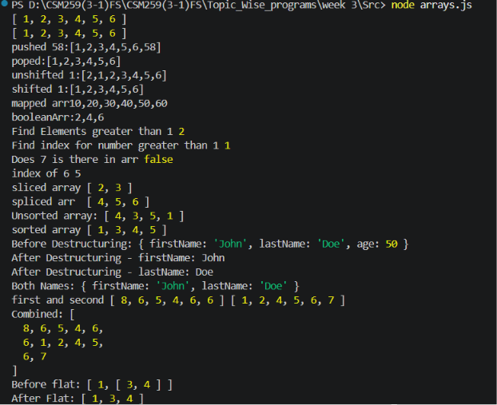

Functions.js
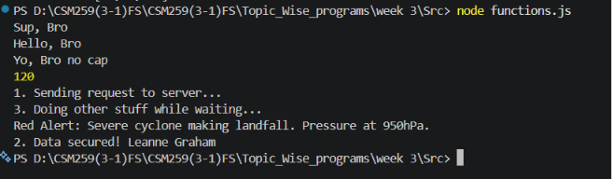

Result: Successfully executed Arrays.js and functions.js using javascript

